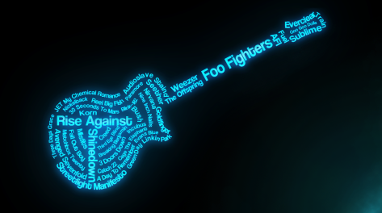
Analyze Your Music!
Name:___________________
Date: ___________ Period:____
Criteria: Song must utilize at least two of the literary elements listed below and be school appropriate. Song Title: ___________________ Artist: _____________
Literary elements evident in my song choice (Circle all that apply)
Plot Conflict Setting Dynamic Character Verbal Irony Situational Irony Allusion Figurative Language

Explain which of the elements you selected is used the most effectively in the song:

Assignment: Find your lyrics online and paste them into the Cornel Notes template on the following page and analyze your lyrics!

Example “Firework” by Katy Perry
Lyrics:  (Identify & Label the Literary Devices) | Explain the Poetic Device Used
1. Do you ever feel like a plastic bag  2. Drifting through the wind  3. Wanting to start again | (simile: you=bag) Poet means like you have no control, pushed around by events  (alliteration: wind, wanting) w sounds give a soft wistful tone adds rhythem and ties the simile to real life
4. Do you ever feel, feel so paper thin  5. Like a house of cards  6 .One blow from caving in | (simile: you=paper/house of cards) Do you feel week, possibly about to give up?  (true rhyme: thin=in) ties the simile to the sentiment of the hyperbole  (hyperbole: you caving in) a person can’t literally cave in from a breath of wind --
Cornel Notes templates: Word - Google Doc

